# KiCAD Layout module

# Scope

This document should be a general guide for common setup of KiCAD layout tool PCBnew supporting

PCB design process.

# General settings

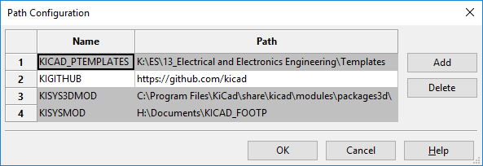

## Text settings

Dimensions→ Text and drawings

| Setting | Value |
| --- | --- |
| Footprints  Edge width (mm): | 0.15 |
| Text thickness: | 0.15 |
| Text heigh: | 1 |
| Text width: | 1 |

## Pads & mask Clearance

It is recommended that the solder paste stencil is just a little bit smaller then the Pad to prevent

solder paste to be applied outside of the copper area.

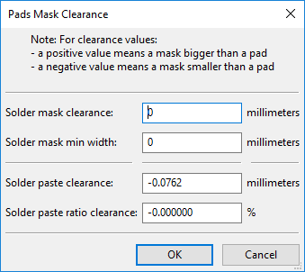

## Grid settings

| Purpose | Grid |
| --- | --- |
| PCB outline | 1mm |
| Component placement | 0.5mm normal  0.05mm fine |
| Layout | Any in 0.05mm  increment |

## Design rules:

The design rules are a set of parameters which are derived from the PCB manufacturing capabillities specification. It includes

minimal clearance, drill hole sizes and milling parameters which need to be adressed in the design process.

So its wise to review the design rules first before starting a new project.

The following settings are general settings which can be used in many cases but it is recommended to consult the PCB supplier.

Navigate to: **Design Rules→ Design Rules**

Tab: **Global Design Rules**

| Setting | Value (mm) |
| --- | --- |
| Minimum track width | 0.1524 |
| Minimum via diameter | 0.5 |
| Minimum via drill dia | 0.3 |
| Minimum uvia diameter | 0.2 |
| Minimum uvia drill dia | 0.1 |

**Custom Track Widths**

|  | Width (mm) |
| --- | --- |
| Track 1 | 0.1524 |
| Track 2 | 0.254 |
| Track 3 | 0.381 |
| Track 4 | 0.508 |
| Track 5 | 0.8128 |
| Track 6 | 1.016 |
| Track 7 | 1.27 |
| Track 8 | 2.54 |

**Custom Via Sizes**

|  | Diameter | Drill |
| --- | --- | --- |
| Via 1 | 0.5 | 0.3 |
| Via 2 | 0.6 | 0.4 |
| Via 3 | 0.7 | 0.5 |
| Via 4 | 0.9 | 0.6 |

# Layer setup

The table below describes the layers which are set up by default in Kicad ( 2 Layer ). If the layer count is increased

more "Inner layer" will be available. Layers can be grouped by purpose into 3 groups: Fabrication layer, Documentation layer and Auxilary layer.

Fabrication layer are the one which will send out to the PCB manufacturing and are the main design layer.

These are used for copper etching, printing screens and to cut masks.

Documentation layer are used for assembly drawings and design data exchange. Auxilary layer provide the designer a visual guide during layout.

| Layer | Description | Type | Note |
| --- | --- | --- | --- |
| F.Cu | Top layer signal | copper | Mandatory layer for production  files |
| B.Cu | Bottom layer signal | copper | Layer for production files |
| In1 | Inner layer signal | copper | Mandatory layer for multi layer PCB |
| F.Adhes | Top layer adhesive layer | adhesive | Only use for wave soldering |
| B.Adhes | Bottom layer adhesive layer | adhesive | Only use for wave soldering |
| F.Paste | Top layer solder paste. | solder paste | For reflow soldering |
| B.Paste | Bottom layer solder paste. | solder paste | Defines which area get solder paste |
| F.SilkS | Top layer printing | silk screen | Component designator printing |
| B.SilkS | Bottom layer printing | silk screen | Part numbers, marking |
| F.Mask | Solder mask opening for pads, via etc. | solder mask | Drawn area is NOT covered with  solder mask |
| B.Mask | Solder mask opening for pads, via etc. | solder mask |  |
| F.CrtYd | Visual support for component placement | mechanical | Not related to production data |
| B.CrtYd | Visual support for component placement | mechanical | Not related to production data |
| F.Fab | Top layer  Component outline for documentation | mechanical | Used to create assembly drawing.  Not related to production process. |
| B.Fab | Bottom layer  Component outline for documentation | mechanical | Used to create assembly drawing.  Not related to production process. |
| Edge.Cuts | Cutting lines | mechanical | Data for milling or groving process |
| Margin | Margin for component placement | mechanical | Board’s edge setback outline |
| Comments |  | auxilary | Not used |
| E.C.O. 1 |  | auxilary | Not used |
| E.C.O. 2 |  | auxilary | Not used |
| Dwgs.User | Used for dimensioning | mechanical | Dimensioning of outline  holes etc. |

# Drawing field

When a layout design file is released the drawing field need to be filled out to clearly identify the document.

The revision field can be filled out by a property window which is integrated in PCBnew.

Navigate to: **File→ Page settings**

Title Block Parameters

| Parameter | Description |
| --- | --- |
| Issue Date | The date of the schematic review |
| Title | The project title which apears on the drawing field |
| Comment 1 | Reviewers name |
| Comment 2 | Material |
| Comment 3 | Drawing reference (project number etc.) |
| Page layout  description field | Chose a drawing frame template.  Department drive:  \13_Electrical and Electronics Engineering\Templates\ |

The revisioning history field need to be filled out manualy by placing a text including name and date.

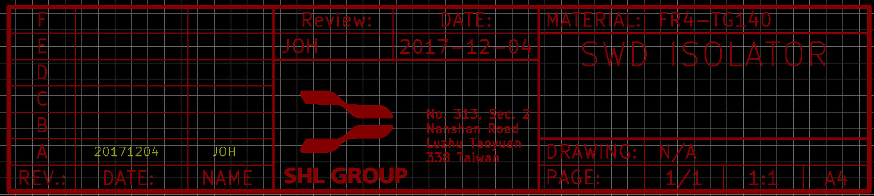

# Generate output files

In PCBnew we will create several types of output files before design freeze.

* Gerber Files
* Drill Files
* Pick & Place
* Assembly drawing

## Gerber Files

Before plotting the files the design should be completed, all changes on the fabrication layers afterwards

need to be updated manually it is also recommended to performe a "Design rule check" and eliminate all design rule violations.

The output files for PCB manufacturing need to be published in Gerber format with Protel file extension format.

All fabrication layer must be plotted in one batch updating afterwards single layers is not the desired way to do.

Navigate to: **File→ Plot**

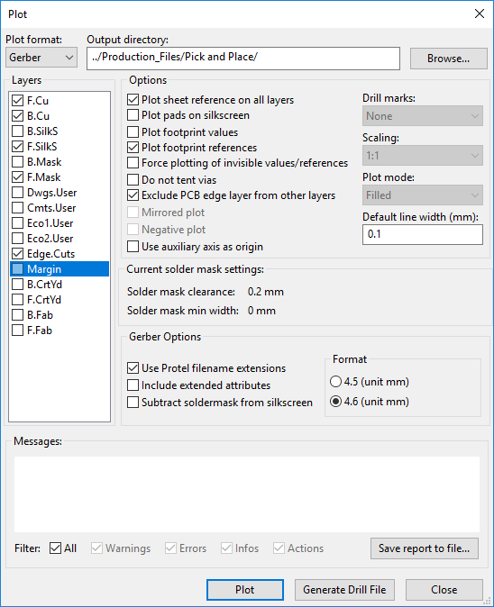

## Drill Files

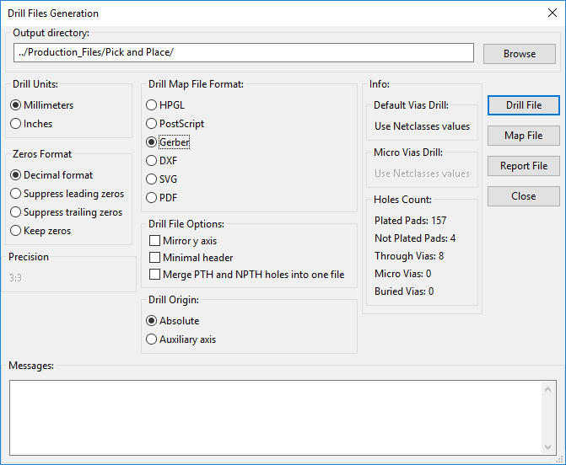

## Pick & Place Files

# References

* PCBnew manual
* IPC-2221